I was unable to go through all of the DevOps Track, so I could work on the Cloud track.

I only got to mess with the Key.

This YouTube was helpful. <https://www.youtube.com/watch?v=33dEcCKGBO4>

Use this if you want to check if you already have an ssh key.

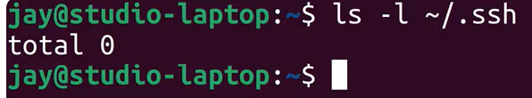

By adding -b 4096(this is bit size) allow you to make a stronger key.



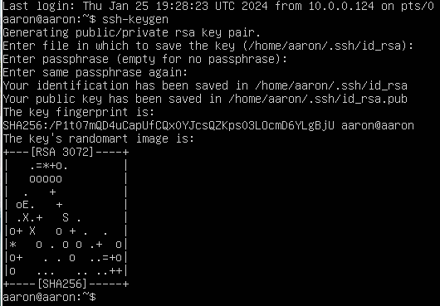

To confirm the key saved or you just want to see it type at the prompt: ls -l ~/.ssh

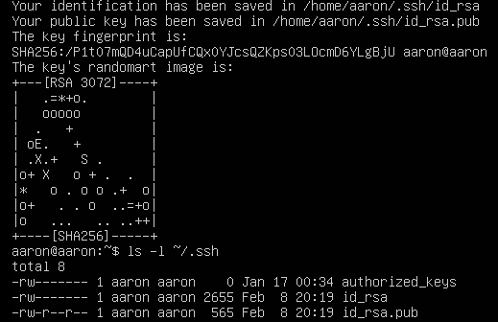

The id_rsa is the private key.

The id_rsa.pu is the public key.

Below is the content of the Public key file. At prompt: cat ~/.ssh/id_rsa.pub

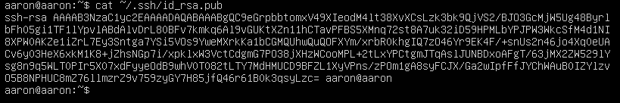

Copying public key to the remote account of my server (see I used IP address below)

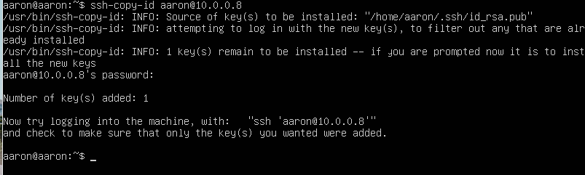

So I had to sign out, and then sign in and try the below.

After I ran, ssh aaron@10.0.0.8 , it asked me for my pass phrase. Once I entered that I got in.



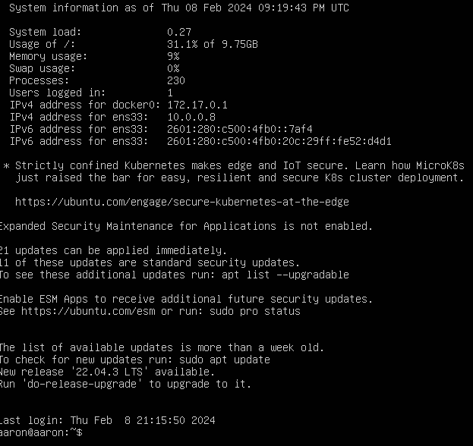

If you look in the ssh file again, you will see a file labeled authorized_keys. This is the same as the public key.

